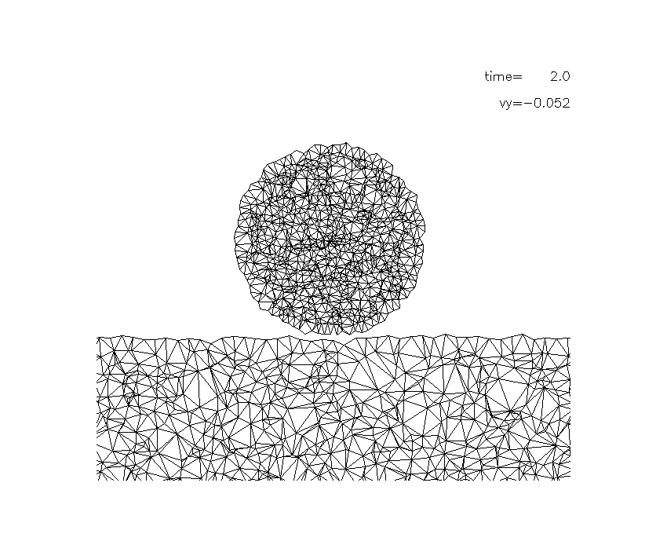
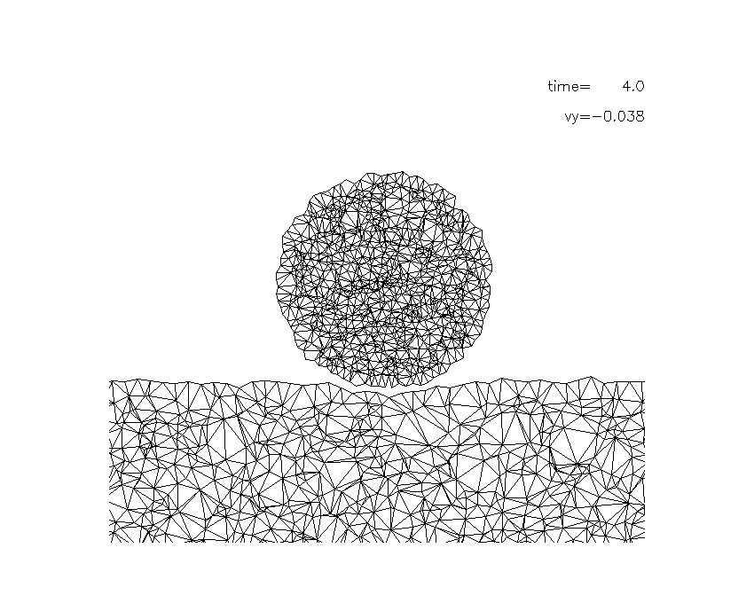
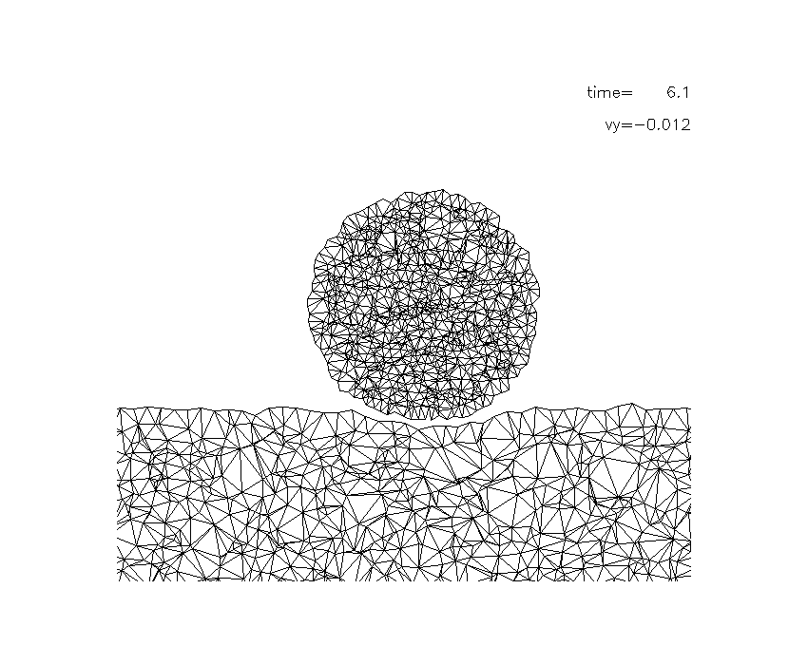
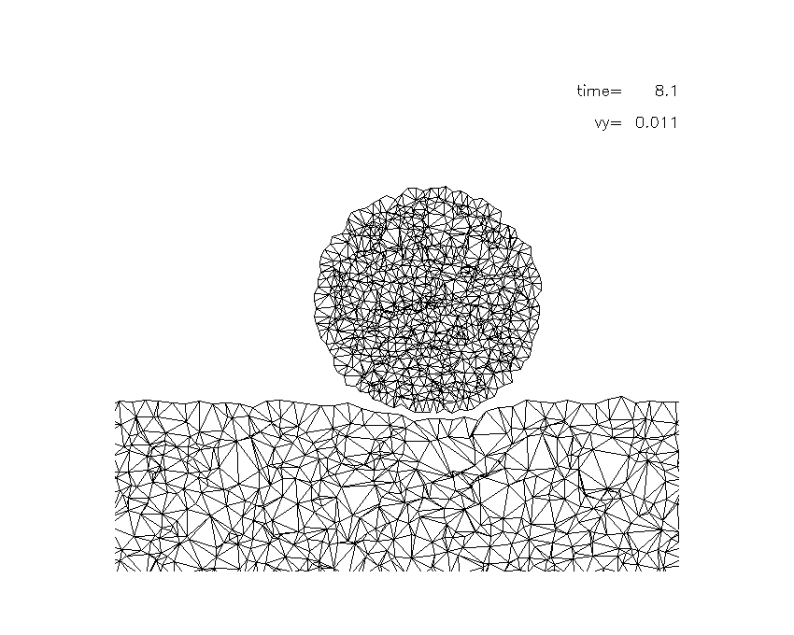
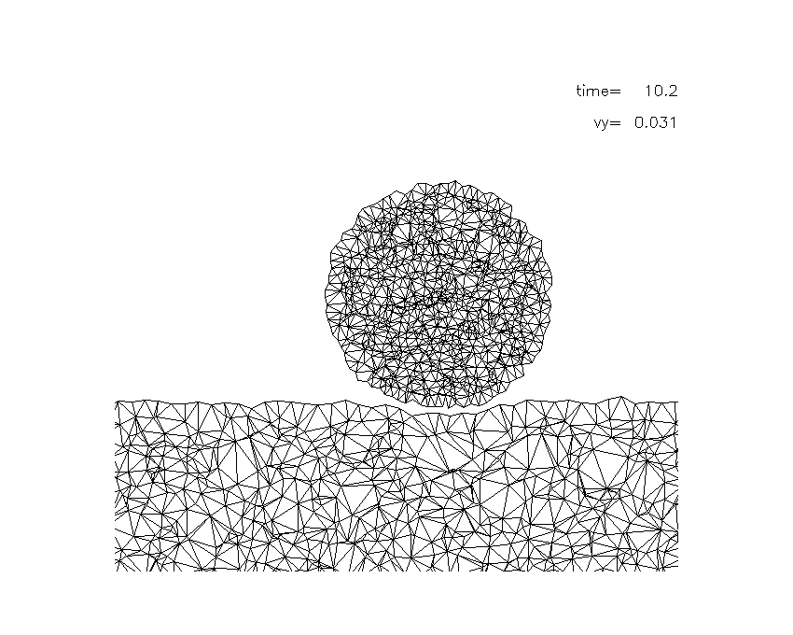
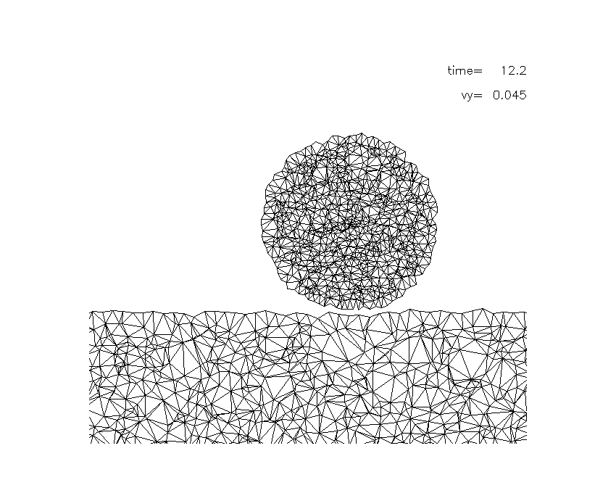
$\text{tan}γ=1$
Incident angle：
(a) t=2.0
(f) t=600
Snapshots of the normal impact process
（a）t=2.0R/c
(b) t=4.0R/c
(c) t=6.1R/c
(d) t=8.1R/c
(e) t=10.2R/c
(f) t=12.2R/c

